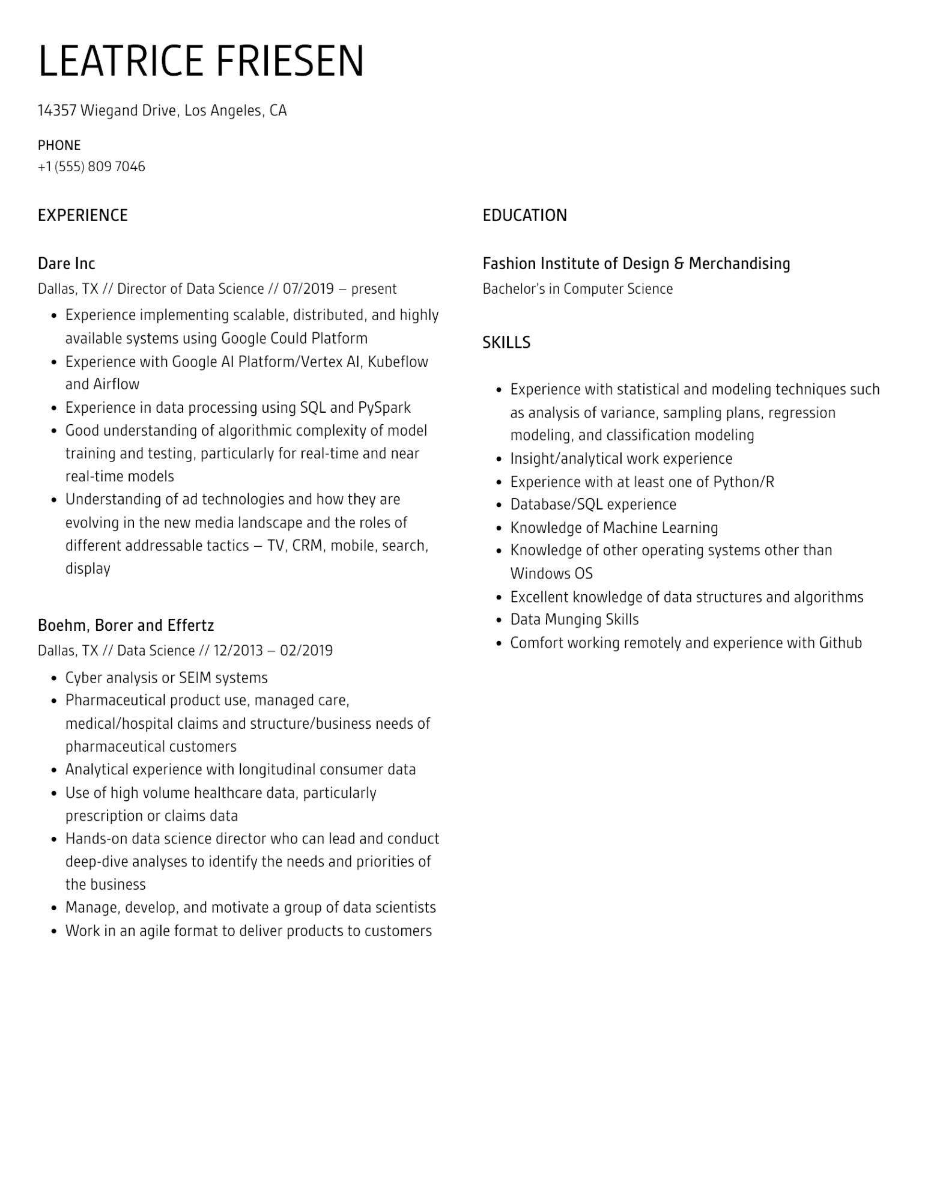
LEATRICE FRIESEN
14357 Wiegand Drive, Los Angeles, CA
PHONE
+1 (555) 809 7046
EXPERIENCE
Dare Inc
Dallas, TX // Director of Data Science // 07/2019 - present
•
•
•
Experience implementing scalable, distributed, and highly available systems using Google Could Platform
Experience with Google Al Platform/Vertex Al, Kubeflow and Airflow
Experience in data processing using SQL and PySpark
• Good understanding of algorithmic complexity of model training and testing, particularly for real-time and near real-time models
Understanding of ad technologies and how they are
evolving in the new media landscape and the roles of different addressable tactics - TV, CRM, mobile, search, display
Boehm, Borer and Effertz
Dallas, TX // Data Science // 12/2013 - 02/2019
•
Cyber analysis or SEIM systems
·
•
Pharmaceutical product use, managed care,
medical/hospital claims and structure/business needs of pharmaceutical customers
Analytical experience with longitudinal consumer data
• Use of high volume healthcare data, particularly
prescription or claims data
• Hands-on data science director who can lead and conduct deep-dive analyses to identify the needs and priorities of the business
•
Manage, develop, and motivate a group of data scientists
• Work in an agile format to deliver products to customers
EDUCATION
Fashion Institute of Design & Merchandising
Bachelor's in Computer Science
SKILLS
•
•
•
•
·
Experience with statistical and modeling techniques such
as analysis of variance, sampling plans, regression
modeling, and classification modeling
Insight/analytical work experience
Experience with at least one of Python/R
Database/SQL experience
Knowledge of Machine Learning
Knowledge of other operating systems other than Windows OS
Excellent knowledge of data structures and algorithms Data Munging Skills
• Comfort working remotely and experience with Github

